

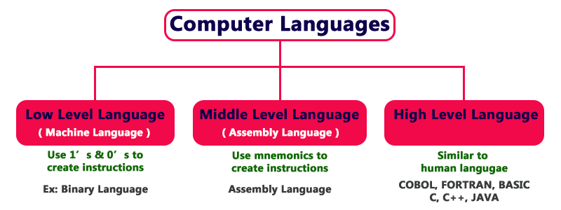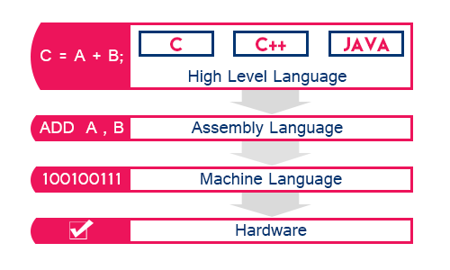

## Machine Language (low level language)

* Low-Level language is the only language
  + which can be understood by the computer.
* Low-level language is also known as **Machine Language**.
* The machine language contains only two symbols **1 & 0**.
* All the instructions of machine language are written
  + in the form of binary numbers 1's & 0's.
* A computer can directly understand the machine language.

## Assembly Language (middle level language)

* Middle-level language is a computer language
  + in which the instructions are created using symbols such as
    - letters,
    - digits and
    - special characters.
* **Assembly language** is an example of middle-level language.
* In assembly language,
  + we use predefined words called mnemonics.
* Binary code instructions in low-level language are replaced
  + with mnemonics and operands
  + in middle-level language.
* But the computer cannot understand mnemonics,
  + so we use a translator called **Assembler**
  + to translate mnemonics into machine language.
* Assembler is a translator
  + which takes assembly code as input and
  + produces machine code as output.
* That means, the computer cannot understand middle-level language,
  + so it needs to be translated into a low-level language
  + to make it understandable by the computer.
* Assembler is used to
  + translate middle-level language
  + into low-level language.
* g++ -S main.cpp -o main.s

## High Level Language

* High-level language is a computer language
  + which can be understood by the users.
* The high-level language is very similar to human languages and
  + has a set of grammar rules
    - that are used to make instructions more easily.
* Every high-level language has a set of predefined words known as Keywords
  + and a set of rules known as Syntax to create instructions.
* The high-level language is easier to understand for the users
  + but the computer can not understand it.
* High-level language needs to be
  + converted into the low-level language
  + to make it understandable by the computer.
* We use **Compiler** or **interpreter**
  + to convert high-level language to low-level language.
* Examples of high-level languages :- FORTRAN,C, C++, JAVA, Python, etc.,
* All these programming languages use human-understandable language
  + like English to write program instructions.
* These instructions are converted to low-level language by the compiler or interperter
  + so that it can be understood by the computer.
* g++ main.cpp



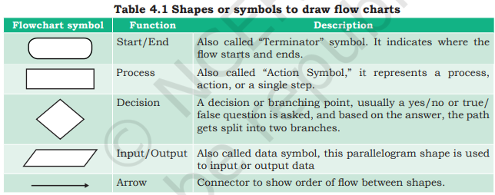



## Flowchart — Visual Representation of Algorithms

* A flowchart is
  + a visual representation of an algorithm.



* A flowchart is
  + a diagram made up of
    - boxes,
    - diamonds and
    - other shapes,
    - connected by arrows.
* Each shape represents
  + a step of the solution process and
  + the arrow represents the order or
  + link among the steps.

